

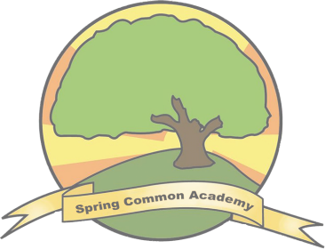
SPRING COMMON ACADEMY

Moving On
OPTIONS

Preparing for Adulthood; A Handbook for Parents
& Carers

2024-2025

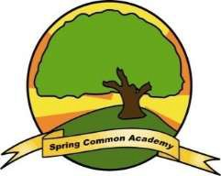


Spring Common Academy

Introduction

The purpose of this booklet is to provide basic answers to some of the most commonly asked questions about Post-16 in Spring Common Academy.
Every student’s needs can be different, and should be discussed in every Annual EHCP review they have from Year 9. Please ensure that you speak directly to our Additional Needs Pathway Adviser Sian Johnson, the school and social care if you have further questions over and above the information enclosed.

There is an opportunity to speak directly to various agencies who make local provision for school leavers or provide advice in an Autumn term ‘Moving On’ evening in November 2025. Parents/Carers and their children are strongly advised to attend.

Our allocated Additional Needs Pathway Adviser (ANPA), Sian Johnson, can assist Year 11/ Post 16 leavers and their parents in the transition process. She can attend annual review meetings and provide up to date careers information, CEIAG and advice on the local offer for individual students. Her contact is:
Sian.Johnson@cambridgeshire.gov.uk

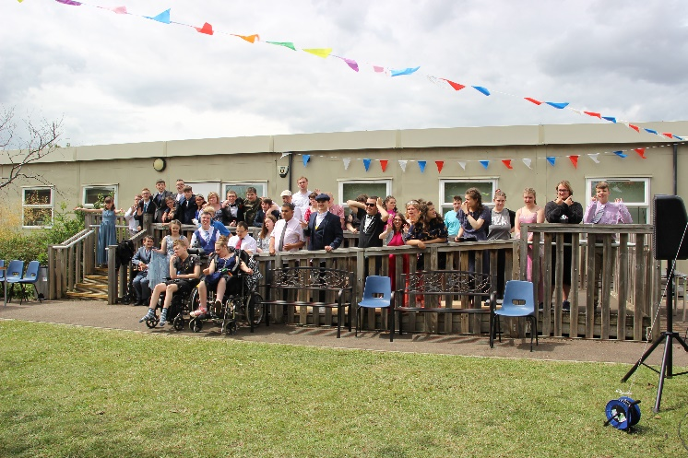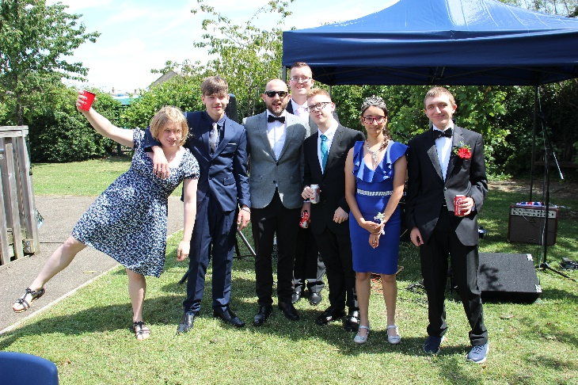

Students celebrating their achievements at the Post 16 Leavers Prom in July 2023


Spring Common Academy
Q&A

When can my son/daughter leave school?
Students are required to stay in education or training until the end of the academic year in which they turn 18. Once they have completed Year 11, they can move onto;

- Full-time education, for example: school or college.
- Apprenticeships – these usually start at level 2. SEND learners working at Entry Level 3 in Maths and English can now apply for an apprenticeship. See here for more details; https://www.gov.uk/topic/further-education-skills/apprenticeships
- Traineeships – these start at Level 1
- Part-time education/ training combined with part time employment/ volunteering for at least 20 hours a week.
- Supported Internships.

When my child leaves school, will the EHCP be continued?
Yes, as long as they are in an education placement, which can last until the student is 25. They will continue to have an Annual Review meeting each year at any further education placement they may attend. If they move to a social care funded provision or to employment before they are 25 the EHCP will cease.

What are the choices open to my son/daughter at 16+?
Please see the Cambridgeshire County Council Moving On document and information online about the local offer. Many opportunities are dependent on the level of the qualification or accreditation they have been working toward in their education placement. If you have further queries please speak to our Additional needs pathway adviser Sian Johnson sian.johnson@cambridgeshire.gov.uk , who will have a clear understanding of the most up to date opportunities available in the local area.

Can my child stay on at SCA Post-16 Provision?
Students wishing to attend Spring Common Academy Post-16 provision must be working below Entry Level 3 in Maths and English.
If your child is working below this level they are able to stay on at Spring Common Academy, if they are working above this level they would benefit from the facilities and level of challenge available at a further education setting. The curriculum at Spring Common Academy works toward Pre-Entry and Entry Level accreditations only.

National qualification levels set by the Department for Education

Pre-entry level courses which provide accreditation of skills not qualifications

Entry level 1-3: pre GCSE level

Level 1 equates to a low end GCSE/BTEC certificate (job examples: Delivery, production line, supervised voluntary etc)

Level 2 equates to a High level GCSE/BTEC first diploma/intermediate apprenticeship (Job examples: Receptionist, Car mechanic, Care assistant etc)

Level 3 equates to A levels/BTEC national diploma/advanced apprenticeship (Job examples: chef, plumber, hairdresser)

Level 4 equates to certificate of higher education/Higher apprenticeships (Job examples: Retail management, accountant etc)

Level 5 and above equates to degree level



Our Post 16 Provision Offer
Post-16 provision at SCA is all about Preparation for Adulthood (PFA). It is focused on enabling students to leave with a set of valuable experiences and transferable skills for life in the following areas;

- Functional Numeracy, Literacy (including Communication) Digital Literacy & ICT.
- Managing good health; physical, social and emotional wellbeing
- Independent living, leisure skills and personal care
- Community link opportunities and relationships
- Employability and enterprise; work related learning skills

Our Post-16 provision offers each student a tailored, personalised curriculum. Our aim is to enable all of our students to reach their potential and to prepare them for adulthood and life after school. Preparation for leaving school will be dependent on individual needs.

Our Post-16 provision area is separate from the rest of the school and comprises of 3 teaching areas, a physio room, a sensory room, a common room and outdoor space to allow greater opportunities for personal development, leisure activities and independence. Post-16 also have use of the adjoining life skills and hospitality/catering suite and the Spring Common Academy retail suite and horticulture environment.

Cambridge Regional College (Huntingdon Campus) School Satellite Provision
Our Post-16 students have regular access to a designated classroom based at the Huntingdon CRC campus. Post-16 students are provided with opportunities to access the different learning environments on offer at the college such as the animal care, horticulture and music spaces. This allows our students to experience aspects of the college environment in preparation for students moving on to further education after Post-16.

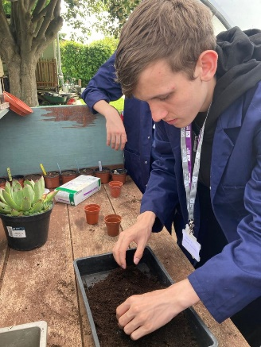
Students continue to have access to any therapies they accessed whilst in KS4 as recommended by appropriate professionals as part of their EHCP provision.

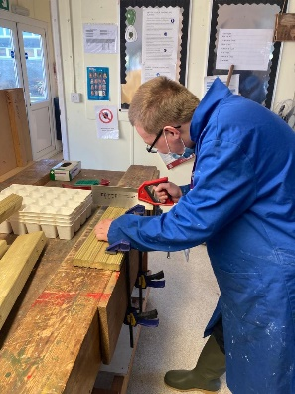

The 16-19 curriculum provision works towards accreditations up to Entry level 3 taught using a range of class based lessons, college links and vocational opportunities on site and in the community including travel training, enterprise projects, community visits and work experience.

Can my child move to college when they are ready?
Students can stay in Post-16 at SCA for 1, 2 or 3 years, and can move on whenever they feel ready and confident enough to make the move. A student’s progress is continually monitored and discussed in their annual EHCP review and evidence of their skills development is recorded in their Progression Profiles.
College Link Subject Examples

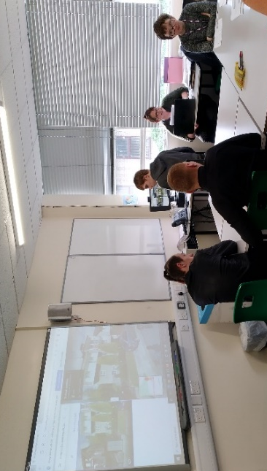
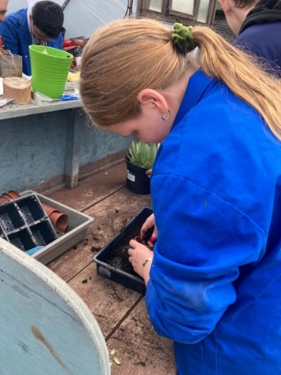
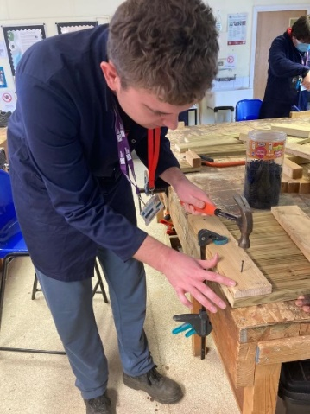
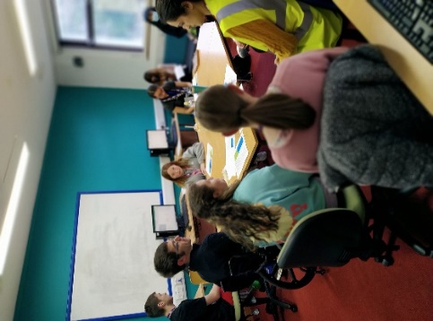
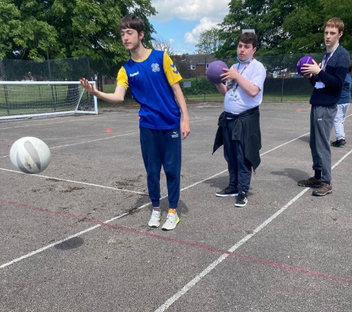
Horticulture
Wood Skills
ICT and Digital Literacy
Cultural Studies
Health and Fitness


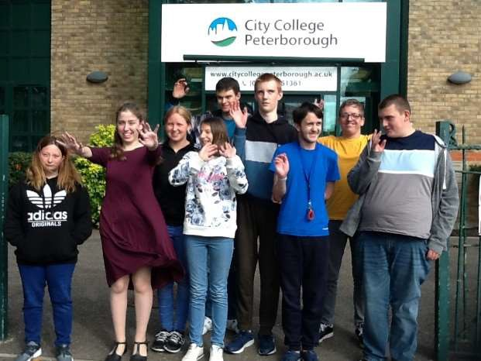
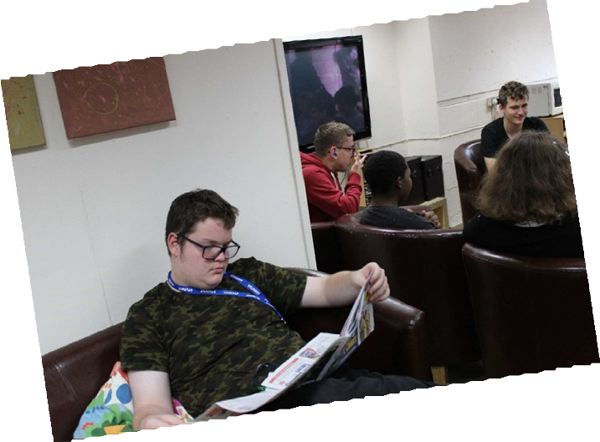
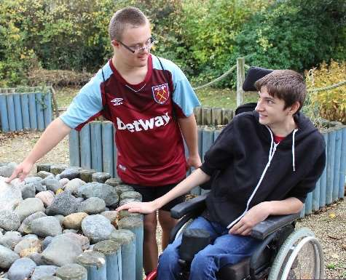
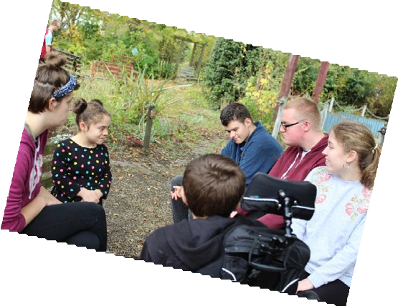

The Student Voice

What do you enjoy as a student of Post 16 at Spring Common Academy?

“You don’t have to be the best, but you should always
try your best” “I learn new things every day in Post 16”

“Uniforms are cool but our own clothes are better, as we have more freedom”

“Post 16 helps you to prepare to be an adult”
5
“Being more independent and doing more mature things like the impressions gym for Senior Games”


How do you prepare students for adulthood and leaving school?
When pupils enter Key Stage 4 (year 10 and 11) they move into the 14-19 phase of learning. The teaching of basic skills in Literacy and Numeracy is central to the curriculum and some pupils will work towards completing Entry Level Certificates whilst others may gain accreditations at Pre-Entry Level. Lessons begin to take on a more practical focus and concentrate on aspects of learning such as life skills, social skills, and independence and employability skills. More emphasis is placed on thinking for themselves and coping in real situations, including the wider world. All students participate in work related learning and enterprise activities including experience of work and have the opportunity to meet the Additional Needs Pathway Adviser. The students’ progress and their next steps is discussed in detail at their EHCP Annual Review.

All SCA students will leave having gained accreditations. In their last year at school, all students will receive nationally recognized certificates at Entry or Pre- Entry Level. All students will receive progression files which detail their personal qualities, aspirations, skills and experiences and listing their educational achievements.
All students will have the opportunity to transition to a further college placement on minimum 3 days a week.

Students may experience different work environments on targeted work placements and participate in the International Enrichment Programme in
Belgium

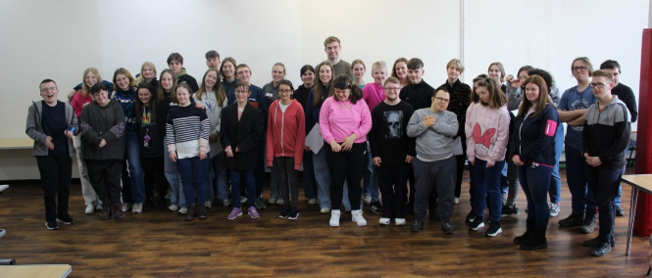
Belgium visitors March 2023

Some students who are assessed as not benefitting from education/employability offers from local further education facilities may be able to access a bespoke provision funded and arranged by social care.

How do you prepare students for their next step?
As part of the Preparation for Adulthood (PFA) curriculum, our pupils are encouraged to examine their likes, interests and strengths. Workplaces, Further Education Colleges and Social Firms are visited and students become familiar with some of the local facilities they may wish to access, once they have left school. In doing this they are also able to start finding out about the opportunities available to them.
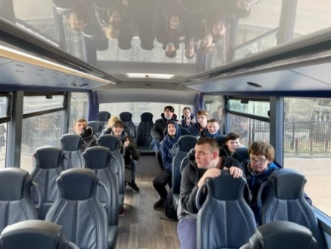
Students may also develop independent travel skills by regularly using a train or public bus as part of their independent travel training to different locations within the community.

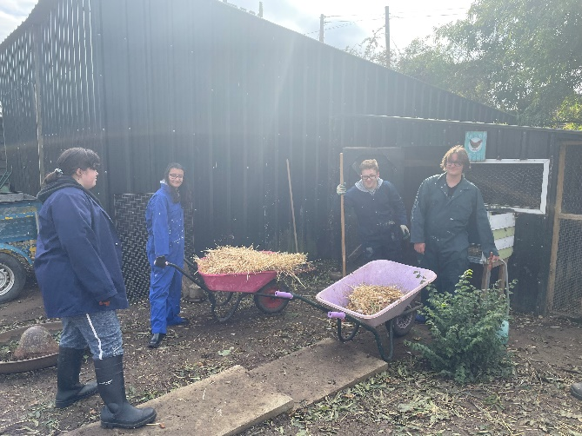
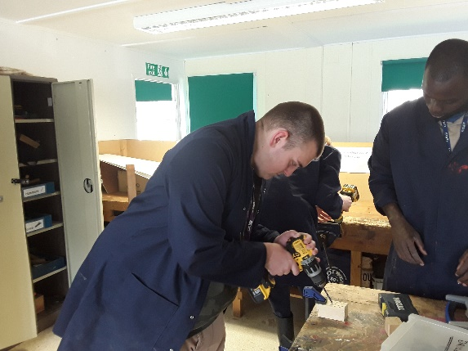

Wood skills college link course
Community Farm Project

How do you prepare students for the world of work?
Spring Common Academy follows a careers strategy programme, which links into the 8 Gatsby benchmarks. More information can be found on our school
website – w ww.springcommon.cambs.sch.uk

- Work Experience Placements
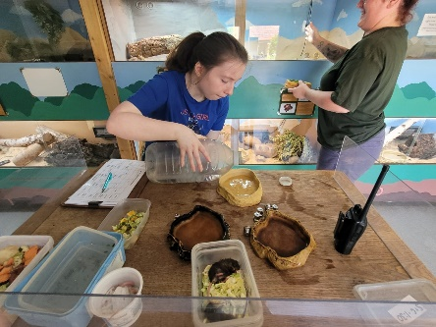
Students in years 12-14 may have a bespoke work experience placement each year, which can be targeted to one day a week, or as a block of 1 or 2 weeks. We have strong links with local businesses but also seek to develop these further to offer a range of different experiences within a workplace environment. These can include visits, taster sessions and partnership projects with a work-related focus.

Vocational Pathways
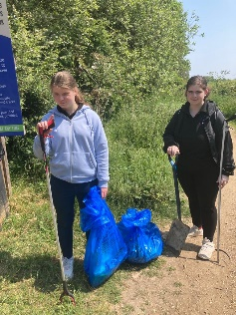
The Post 16 curriculum has a range of dedicated sessions of vocational training opportunities and may include Horticulture, Catering and Hospitality and Retail on and off site. This enables our students to gain a greater understanding of the working world and develops employability skills.

Work Related Learning and Enterprise (WRLE)
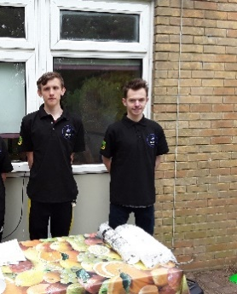
Curriculum time is dedicated to WRLE in KS4 and 5 in order to develop communication, functional and independent skills in our students as they work in teams to evolve an entrepreneurial culture and focus

Vocational / Progression Profiles
All pupils have a Progression profile developed over time from year 9 within the annual review process. It is a document driven by the student’s aspirations and interests, and should be continued with their next provider. At SCA, it is a working document changing as the student matures and grows. They have ownership over the document and use it to lead their own annual review meetings. Those students with employability outcomes will complete these as part of our CEAIG program with our dedicated ANPA. The documents are vitally important for anyone who will provide assistance to the student, in order to obtain and maintain integrated employment in the community if appropriate.
The school uses the prompt questions taken from the Cambridgeshire County Council version, but use PowerPoint and Communicate InPrint software to support our cohort’s receptive communication.

Our Students in work placements…

Raptor Foundation
The Grey House cafe

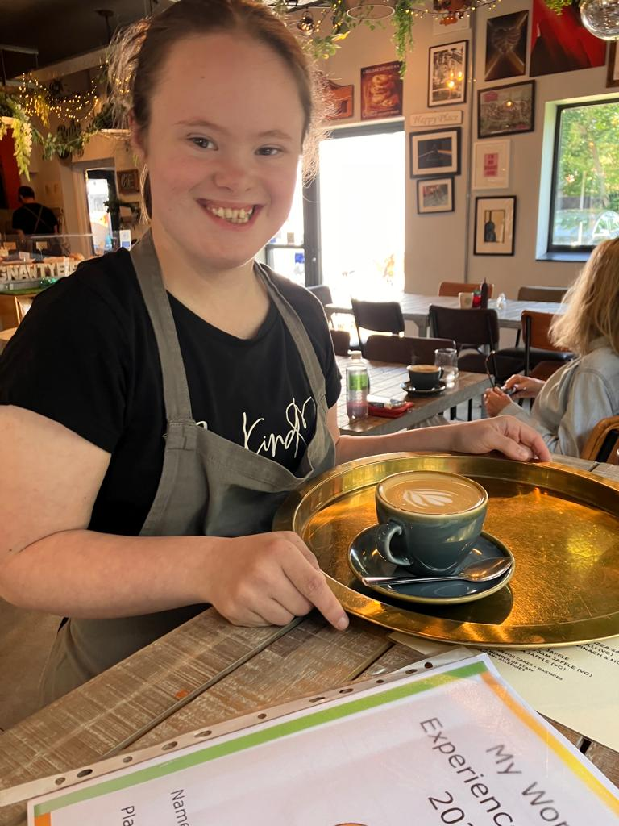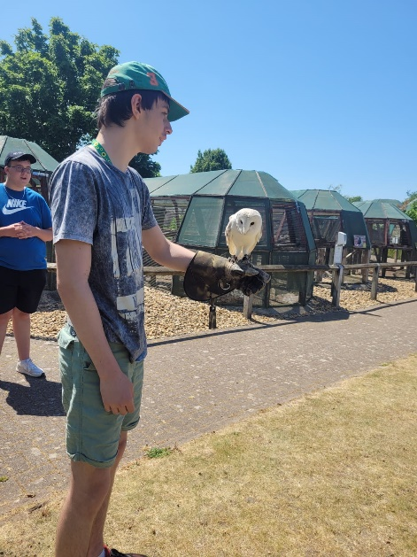

The Attic
Mick George

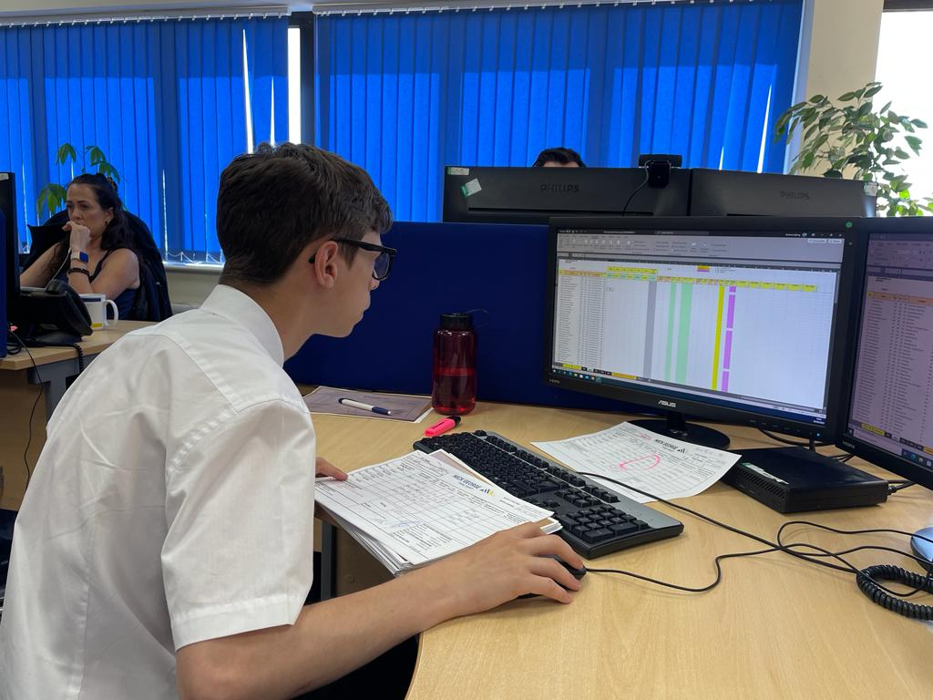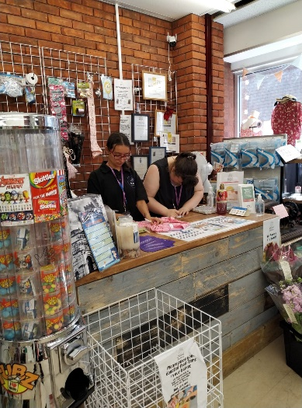

Who pays for my child’s Further Education?
Please see the Cambridgeshire County Council ‘Moving On’ booklet for more information.

How will my child get to college if attending full time or part time?
Please see the County Council ‘Moving On’ booklet for more information.

How long do college courses last?
This can vary depending on the college course attended. Open evenings are held each year and information on learning support may be obtained. Parents and students are encouraged to attend these open evenings. Many courses are only 3 days a week.

If my child has received respite care whilst attending school, will this continue after he/she has left?
Children’s Disability Service will work with children with learning disabilities up to 18 years of age. The Young Adults Team (YAT) will then take over and complete an adult assessment. They will continue to support the young person up to 25 years if needed.

We might like to apply for a long-term care placement for our child. How do we go about this?
If your child wants to leave home or go into supported living, you will need to talk to your social worker or adult support coordinator. You can also contact Adult Services Contact Centre on 0345 045 5202. If the young person is under 18, please call 0345 045 5203.
If you wish for your child to go straight into long term care when school or college finishes, it is essential you make your wishes known to them well in advance. The planning preparation for this requires a great deal of time. More information can be found in the enclosed ‘Moving On’ booklet.

Upcoming College Open Days 2024-2025

Cambridge Regional College, Huntingdon Campus
Saturday 9th November 2024 9:30-12:30 Open Day
Thursday 21st November 2024 6-7:30pm Apprenticeship Information Evening
Thursday 6th March 2025 4-6pm Apprenticeships, Jobs and Careers Fair and Open Day
Saturday 28th June 2025 10:30-1pm Open Day and Fun Day

Cambridge Regional College, Cambridge Campus
Saturday 16th November 2024 9:30-12:30 Open Day
Tuesday 19th November 2024 6-7:30pm Apprenticeship Information Evening
Saturday 25th January 2025 10-12:30pm Open Day
Tuesday 4th March 2025 4-6pm Apprenticeships, Jobs and Careers Fair
Thursday 24th April 4:30-7pm Open Day
Tuesday 1st July 2025 Open Day

Peterborough City College, John Mansfield Campus
Wednesday 13th November 4-6pm
Tuesday 3rd December 4-6pm
Tuesday 21st January 4-6pm

Peterborough Regional College
Tuesday 26th November 5:30pm
Thursday 30th January 5:30pm

College of West Anglia (sites in Kings Lynn, Downham Market, Cambridge and Wisbech)
13th November 5-8pm Downham Market SEMH Provision
23rd November 9-12:30 Wisbech campus
23rd November 9-12:30 Cambridge campus

Please check each college website for further dates, information and registering for each event.

We hope you have found this booklet useful. Leaving school is a major step for both students and their families and every single circumstance is different. If you have any further queries concerning your child’s future, please do not hesitate to let us know at school and we will be able to help by putting you in contact with the right people.

Tilly Newbury – Post-16 Lead
tnewbury@springcommon.cambs.sch.uk

