
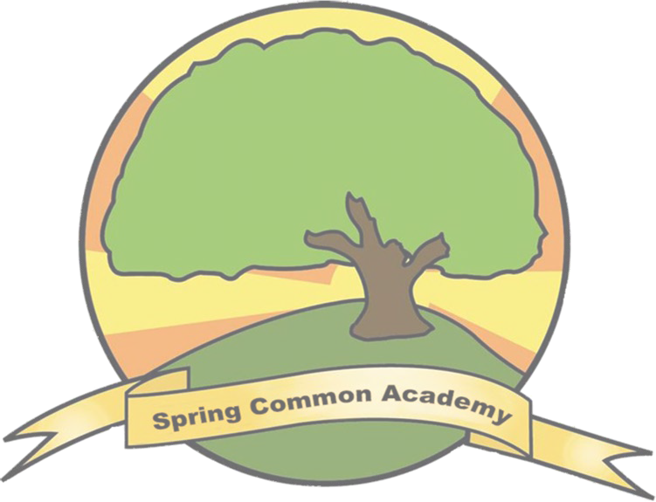

SPRING COMMON ACADEMY

The Gatsby Benchmarks

THE GATSBY BENCHMARKS ARE THE RESULT OF AN INTERNATIONAL STUDY TO FIND THE BEST PRACTICE IN CAREER GUIDANCE WORLDWIDE. FROM THIS
STUDY, EIGHT BENCHMARKS WERE DRAFTED WHICH DEFINE THE ESSENTIALS OF GOOD CAREER GUIDANCE. SPRING COMMON ACADEMY HAVE DEVELOPED A
FRAMEWORK BASED ON THESE EIGHT BENCHMARKS, WHICH REFLECTS OUR COMMITMENT TO EXCELLENT PRACTICE IN CAREER GUIDANCE.

This document was produced by Tilly Newbury, Post 16 Manager.


Benchmark Summary & Criteria Spring Common Academy Outcomes
1 A STABLE CAREERS PROGRAMME | Every school and college should have an embedded programme of career education and guidance that is known and understood by students, parents, teachers, governors and employers.  - Every school should have a stable, structured careers programme that has the explicit backing of the senior management team, and has an identified and appropriately trained person responsible for it.  - The careers programme should be published on the school’s website  in a way that enables pupils, parents, teachers and employers to access and understand it.  - The programme should be regularly evaluated with feedback from  pupils, parents, teachers and employers as part of the evaluation process. | - We ensure a stable Careers programme through our Careers Education, Information, Advice and Guidance (CEIAG) Policy which outlines the School ethos, aims, delivery and content, partnerships, monitoring and evaluation of how our Careers programme is embedded across the school.  - We provide students with taster opportunities, work experience, mentoring, enterprise education, access to role models and inspiring activities in school and in the community to raise aspirations for future destinations.  - In preparation for adulthood, students learn independent life and living skills, travel training, PSHE and community participation.  - The whole school has opportunities across the curriculum to develop transferable life and social skills that support careers, employability and enterprise through our Lifeskills Challenges. This includes the development of students’ self- advocacy, negotiation, decision-making and transition skills - purposeful interactions with a range of trusted and familiar adults including school staff and visitors.  - The Post 16 manager leads and co-ordinates the careers programme and engages with community partners. We also have a Trustee Representative who takes a strategic interest in careers education, and a Vocational Support Administrator in post.
2 LEARNING  FROM CAREER AND LABOUR MARKET INFORMATION | Every student and their parents should have access to good quality information about future study options and labour market opportunities. They will need the support of an informed adviser to make best use of available information.  - By the age of 14, all pupils should have accessed and used information about career paths and the labour market to inform their own decisions on study options.  - Parents should be encouraged to access and use information about  labour markets and future study options to inform their support to their children. | - Earwig, work experience diaries, pupil progression profiles and wall displays show our students visiting and participating in work experience opportunities in a range of sectors.  - Local employers (ref Benchmark 6 for examples of employer partnerships), participate and support our young people in Work related learning events held in school e.g. Macmillan Coffee Mornings, School Shop etc.  - Year 10-14 students carry out job roles and responsibilities within the School Shop, Polytunnel, office and at whole school events etc. developing communication and independence skills, and as role models for younger students and parents.  - Our school website (www.springcommon.cambs.sch.uk) signposts parents to organisations e.g. pinpoint with information and experience of career pathways and progression routes. Yr 9 and KS4/5 have targeted sessions with ANPA to discuss careers and up to date routes to careers.  - We offer our skills and professional knowledge base to support local businesses and other schools in the Cambs Outreach programme, to learn more about disability and diversity. E.g. Students commissioned to produce an Autism friendly guide for visitors to the Norris Museum in St Ives.

Benchmark Summary & Criteria Spring Common Academy Outcomes

- ADDRESSING THE NEEDS OF EACH STUDENT

Students have different career guidance needs at different stages. Opportunities for advice and support need to be tailored to the needs of each student.

- A schools careers programme should actively seek to challenge stereotypical thinking and raise aspirations.
- Schools should keep systematic records of the individual advice given to each pupil and subsequent agreed decisions.
- All pupils should have access to these records in order to support their career development.
- Schools should collect and maintain accurate data for each pupil on their education, training or employment destinations.
LINKS TO BENCHMARK1
- Our students lead and participate in their annual EHCP Review meetings which help set out goals and support needs in relation to: moving into paid employment and higher education, independent living, having friends and relationships, being an active member of the community and living a healthy lifestyle.
- EHCPtargetsarelinked to the Preparation For Adulthoodoutcomes. PFA themes are used in student’s progression profiles which detail aspirations for all pupils in year 7 and above. (www.preparingforadulthood.org.uk)
- Students and families in Year 9 and above all receive a comprehensive ‘Moving On’ Options & Preparing for Adulthood handbook. All are invited to attend the ‘Moving On Options’ evening- a future aspirations information, advice and guidance fair. All families have access to the ‘Moving on’ page on the school’s website.


CURRICULUM LEARNING TO CAREERS

All teachers should link curriculum learning with careers. STEM subject teachers should highlight the relevance of STEM subjects for a wide range of future career paths.

- By the age of 14, every pupil should have had the opportunity to learn how the different STEM subjects help people to gain entry to, and be more effective workers within a wide range of careers.
- All pupils from year 7 and above begin to develop their ‘progression profile’ using the Cams Vocational Profile prompts adapted to a visual format they detail ‘an individual’s experience, skills, abilities, interests, aspirations and needs in relation to employment. The aim is to understand the person in-depth and to allow for the best possible job match or work experience placement. It provides a picture of the ideal conditions needed in a workplace for the student to be successful.”
- Careers as a cross curricular subject gives young people access to both work-related experiences and explicit skills-functional Maths, English and ICT, alongside ensuring the subject curriculum relates to the workplace. Our CEAIG programme incorporates a broader curriculum of independent living skills, social skills and travel training delivered by regular staff at school and with the local College travel trainer for transitioning as required. We have a tailored approach to provide a balance between different elements of learning, such as class-based, community based, work experience or enterprise activities to develop transferable career skills and we draw on real-world contexts to boost confidence and understanding. Refer to Part 1 of the ‘Moving On’ Options Booklet for more information.



Benchmark Summary & Criteria Spring Common Academy Outcomes
5 ENCOUNTERS WITH EMPLOYERS AND EMPLOYEES | Every student should have multiple opportunities to learn from employers about work, employment and the skills that are valued in the workplace. This can be through a range of enrichment activities including visiting speakers, mentoring and enterprise schemes.  - Every year, from the age of 11, pupils should participate in at least one meaningful encounter* with an employer.  *a ‘meaningful encounter’ is one in which the student has an opportunity to learn about what work is like or what it takes to be successful in the workplace. | A young person who has four or more meaningful encounters with an employer is 86% less likely to be unemployed or not in education or training (NEET) (Education and Employers taskforce 1998)  We commit to building high expectations in our SEND learners by giving our Entry Level learners encounters with employers on multiple occasions. In one of three ways:  - Our onsite work experience (shop, catering and hospitality and horticulture, all of which involve an enterprise and retail element). We invite employers and families in to the school for events  e.g. the 2 day Macmillan Coffee Mornings (200 customers), Restaurant Days, themed shop days selling enterprise goods.  - Through off site group community Work Experience placements e.g. Norris Museum, nursery, nature reserve  - Individualised placements in local workplaces where appropriate for learners, e.g. local book shop, cafes or childcare facilities.  - Termly ongoing placement in Mick George construction company, involving office and administrative work.  All of which are opportunities for our students to learn in an age appropriate, progressive way about work, employment and skills that are valued in the workplace.  We celebrate employability skills at our KS4 and KS5 leaver’s assemblies.  From years 7-11 our students will experience many encounters with employers and employees, through an extensive range of community visits as part of their ‘personal development’.  Our Moving On event and booklet shows our strategic approach and shared sense of purpose with key partners including parents/carers, employers, teachers and other agencies to offer relevant and updated information about future pathways.
6 EXPERIENCES OF WORKPLACES | Every student should have first-hand experiences of the workplace through work visits, work shadowing and/or work experience to help their exploration of career opportunities, and expand their networks.  -By the age of 16, every pupil should have had at least one experience of a workplace, additional to any part- time jobs they may have.  - By the age of 18, every pupil should have had one further such experience, additional to any part-time jobs they mayhave. | Linking to Benchmark 5.  - Our offer of meaningful experiences includes a range of possible workplace visits, work shadowing, work experience and career-related volunteering and citizenship. We have a graduated programme of employer engagement for our learners, and record and monitor each individual’s range of experiences to provide breadth of opportunity. Placements have included supermarkets, offices, care homes, restaurants, country parks, museums and other local businesses/organisations as well as internal work placements with site manager etc.  - Where possible students will be independent in the work place, but we offer employers support materials e.g communication passports, specialist resources and job mentors bespoke to individual needs of learners/employers as part of the preparation and planning. Students compile journals of their experience to share with employers, families and peers.  - Post 16 curriculum offers learners the opportunity to explore vocational pathways in Retail,  Horticulture, Catering and Hospitality and volunteering. We find all these experiences help with transition confidence, self-esteem and personal development in preparation for adulthood.



Benchmark Summary & Criteria Spring Common Academy Outcomes
7 ENCOUNTERS WITH FURTHERAND HIGHER EDUCATION | All students should understand the full range of learning opportunities that are available to them. This includes both academic and vocational routes and learning in schools, colleges, universities and in the workplace.  - By the age of 16, every pupil should have had a meaningful encounter* with providers of the full rangeoflearningopportunities, includingSixthForms, colleges, universities and apprenticeship providers. This should include the opportunity to meet both staff and pupils.  - Bytheageof 18, allpupilswhoareconsidering applyingfor universityshould have had at least two visits to universities to meet staff and pupils. | - For year 12, 13 and 14 students, we offer an extensive 3 year College Link programme with local  F.E Colleges i.e. Cambridge Regional College, in years 12-14. We widen this to year 11 and other Colleges if a bespoke transition programme is required for learners in their final year.  - Our young people learn about post-compulsory schooling options in a range of ways including through direct interactions with the lecturers, college environments, current students and alumni.  The Moving On and transition fair allow students and families to find out about courses, and to explore the full range of routes available including their local college, apprenticeships, traineeships, vocational opportunities, employment. Also discussed with ANPA in KS4 and KS5 Annual Reviews where appropriate.  We work in close partnership with our local F.E provision and share best practice to meet the needs of our learners and their complexities. We carry out quality assurance and monitor delivery through the Service Level Agreements (SLA), Learner Review documentation and College Learning Walks by School SMT.  On top of the college link programme, we have a designated classroom located at the local Cambridge Regional College (Huntingdon) campus which students can access throughout the week in order to gain early access to the college learning environments.
8 PERSONAL GUIDANCE | Every student should have opportunities for guidance interviews with a career adviser, who could be internal (a member of school staff) or external, provided they are trained to an appropriate level.  These should be available whenever significant study or career choices are being made.  - Every pupil should have at least one such interview by the age of 16, and the opportunity for a further interview by the age of 18. | Cambridge County Council and review a Partnership Agreement annually to provide access for all students to a specialist careers adviser – an Additional Needs Pathway Adviser (ANPA) who works with school, students and their families from year age 14-25 to provide consistent, ongoing support for the transition to adult life. ANPA attendance at EHCP annual transition reviews, supports our commitment to helping students and parents to understand progression pathways and through interagency collaboration, to develop strategies and advice on how to achieve their goals.  - Career guidance activities include listening to students’ initial ideas, qualifications, skills, experiences, circumstances and life aims – All About Me profiles, 1:1 discussions etc. - helping students to identify and explore suitable options, in preparation and prior to any meetings/reviews.  - Vocational profiles are beginning to become a useful tool as part of the provision of information, advice and guidance services.  - The Moving On options books, Transition events and CEIAG forums and Preparation For  Adulthood Manager are all available resources to offer personal guidance to learners, and to provide training and briefing sessions to staff on CEAIG.

