

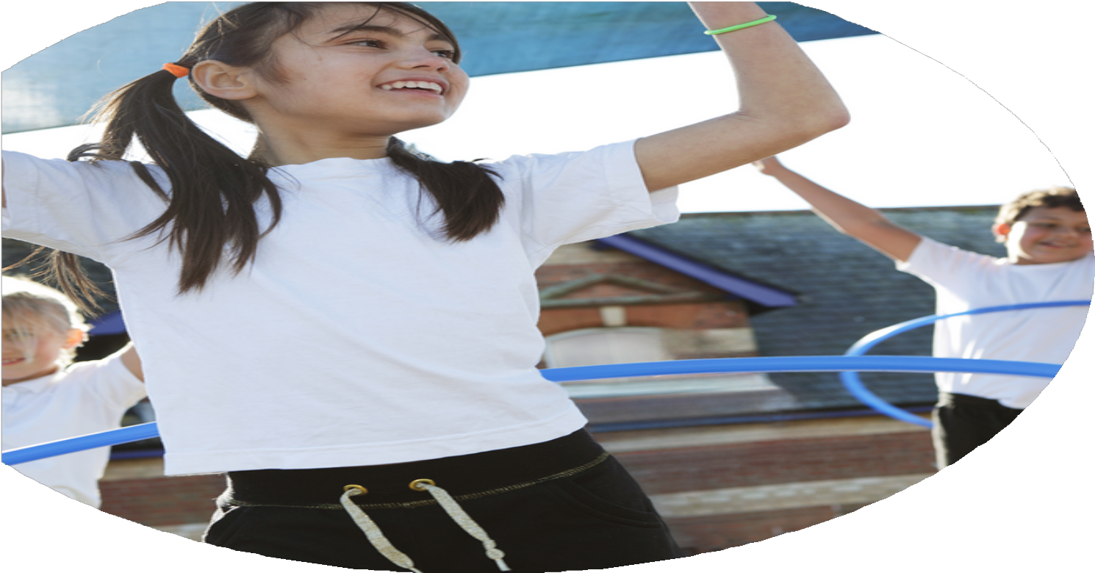
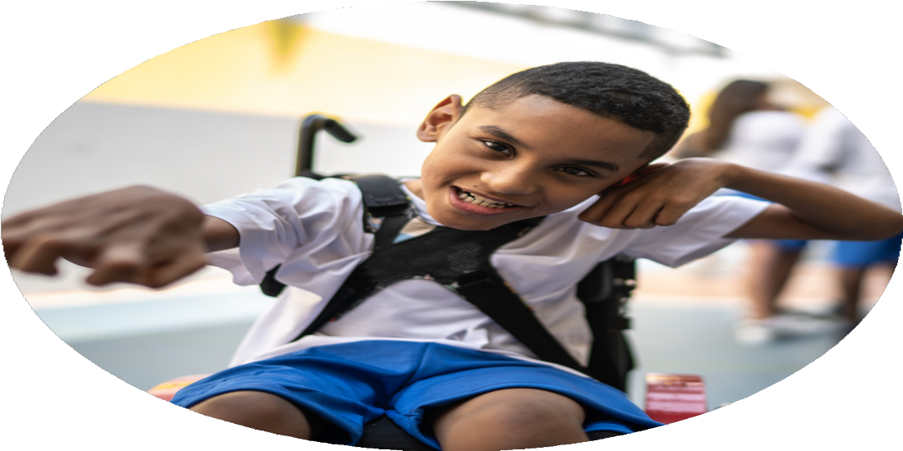
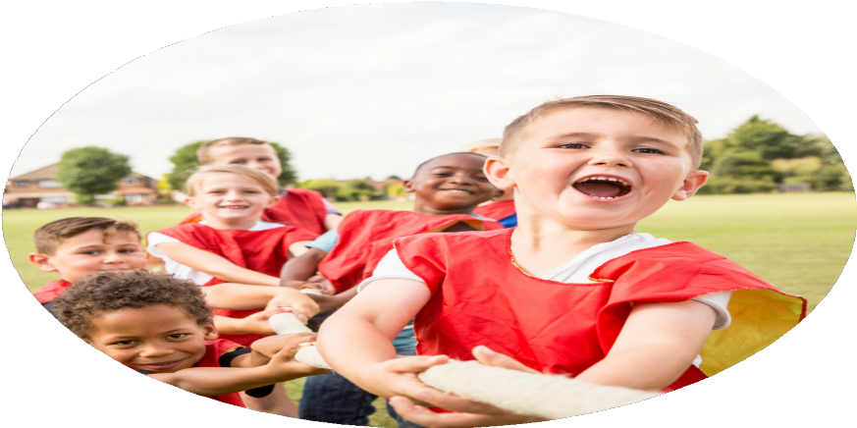



PE Funding

Evaluation Form

Commissioned by

Created by

Images courtesy of Youth Sport Trust

PE Funding Evaluation Form

It is intended that this template should be used as preparation for the completion of the statutory digital reporting tool being introduced this academic year. You can upload data (including swimming) from this template onto this platform once it becomes accessible.
Before you decide how you are going to use the funding for this academic year you should reflect and evaluate the impact of your use of the funding in 2023/24.
All spending of the funding must conform with the terms outlined in the Conditions of Grant document. The template is a working document that you can amend/update during the year.
Based on your evaluation of last year’s funding you should decide what you intend to do this academic year, how you will do it, and what impact you expect it to have.

It is important that the funding is used effectively and based on your school’s needs.
You must use the funding to make additional and sustainable improvements to the PE and sport in your school. You must develop and add to the PESSPA activities that your school already offers.

Summative digital reporting from June 2025 will continue to include swimming and water safety information therefore funding can be used to provide top-up lessons where necessary to ensure pupils meet national curriculum swimming requirements.

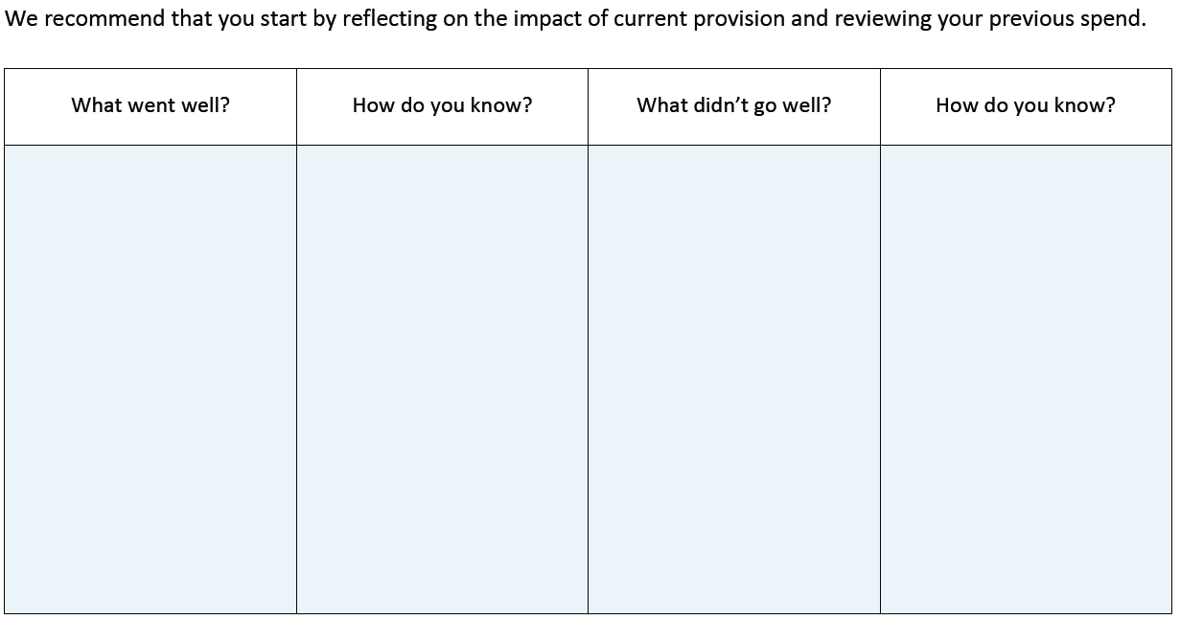
Reduced use of the trampolines over the past year has meant that the steps have been used less.
Trampoline foam Steps

Feedback from our Early Years and KS1 teachers to say how much the pupils enjoy the new equipment and how much they engage with them.
Increased access for our younger pupils to engage in physical activities such as running and climbing.

Our pupils get so much out of our horse riding sessions, including increased mobility, core strength, balance and coordination. This is seen through visually observing the pupils and their improvements.

Pupils who are otherwise unable to access our Sports Hall to join in with lessons are able to access sporting activities through the Jump for Joy set. Feedback from teachers state how certain pupils engage with this set.
Improvements to our Early Years & KS1 Playground

Woodhurst RDA Horse Riding Sessions

Jump for Joy Sports Set

What are your plans for 2024/25?

Intent
How are you going to action and achieve these plans?

Implementation
Sensory Equipment for our pupils with sensory needs - £83.00
Restock of arm bands and tummy bands to build water safety, confidence and independence - £797.28
Current Spend: £880.28

Purchase of cycling helmets to allow for greater pupil participation - £218.00
Purchase of bicycle care kits, pumps and inner tubes for the repair and upkeep of current bikes - £655.52
Purchase of a hand cycle for less able pupils to participate in cycling sessions with their peers - Tomcat Handy - £5,617.20 (tomcat.org)
Current Spend: £5,835.20

Fine motor skills pack (x10) - £670.00 (sportsdirectory.com)
Current Spend: £670.00

Book use of Woodhurst RDA horse riding for the academic year 2024/25
Current Spend: £720.00

Swimming
Increase inclusion and participation in swimming for our primary aged pupils with additional needs.
£1,000 to be allocated

Cycling
Increase participation in cycling for our less able pupils, and improve cycling proficiency
£6,000 to be allocated

Lower School Fine Motor Skills
Build a bank of resources for our lower school pupils to use in their classes to build pupil’s fine motor skills. Use resources as part of both regulation and improvement of basic PE skills.
£700 to be allocated

Horse Riding
Continue our horse riding provision for pupils who benefit from the physical aspects of these sessions
£720 to be allocated

Book out use of Huntingdon Gym to offer pupils the chance to use the excellent facilities there, and to be led by an experienced coach
Current Spend: £3,420

Action Packed Action Mats Set - £910.00 (sportsdirectory.com)
First-Play Mega Target Pack - £190.00 (sportsdirectory.com)
First-play Movement Activity Pack - £85.00 (sportsdirectory.com)
Current Spend: £1,185

Sure Shot Squash rebound wall - £222.19 (hope-education.co.uk)
Progress Squash Balls - £12.00 (sportsdirectory.com)
First-play Junior Parachute resource kit - £100.00 (sportsdirectory.com)
Slazenger Safety Soft Foam Dodgeball Pack - £135.00 (sportsdirectory.com)
KS2 Flag Football Coaching Pack - £300.00 (sportsdirectory.com)
Bowling Set (x2) - £72.00 (sportsdirectory.com)
Foot golf Target & Flags - £495.00 (sportsdirectory.com)
Volleyball progression pack - £125.00 (sportsdirectory.com)
First-play Floater Ball Pack - £58.00 (sportsdirectory.com)
First-play Orienteering Starter Pack - £100.00 (sportsdirectory.com)
6mm Polyethylene Rope - £50.00 (sportsdirectory.com)
High Jump Stand (Senior) - £135.00 (sportsdirectory.com)
Deluxe PE Storage Trolley (x3) - £1225.00 (sportsdirectory.com)
New Stereo system for the Gym - £140.00 (amazon.co.uk)
Portable Bluetooth speaker for taking outside - £110.00 (amazon.co.uk)
Current Spend: £3,279.19

Total Spend: £15,989.67
Gymnastics
Continue our offer for sessions at Huntingdon Gymnastic center, using their amazing resources as an extracurricular activity.
£3,420 to be allocated

Lower School PE Provision
Increase our resources for our EYFS, KS1 and KS2 classes who struggle to engage in PE lessons so they can participate in PE through play in and around the classroom.
£1,200 to be allocated

PE Equipment (£3,300)
Improve our curriculum offer and provisions in PE and sports for our primary aged pupils through purchasing and restocking equipment.
Purchase resources to allow for a greater range of sports and physical activities for our pupils.

What impact/intended impact/sustainability are you
expecting?
How will you know? What evidence do you have or
expect to have?
- Feedback from teachers about their pupils engagement in PE

- Feedback from parents about their child’s improvements outside of school

- Visual observations of the pupils in relation to their coordination, posture, and mobility

- Assessment of our pupils in both PE and swimming to keep track of their progress
- An increased participation in physical activity for all of our pupils

- Improved balance, coordination and core strength for our pupils who have limited access to PE

- Pupils to build their cycling proficiency, knowledge and safety to use in the wider community

- A wider, more inclusive PE curriculum for our pupils, which will be fully resourced.

- More outside equipment for pupils to access at playtimes that will lead to an engagement in physical activity

What impact/sustainability have you seen?
What evidence do you have?
- Feedback from teachers via a survey. Positive comments about the variety of different activities

- Positive feedback from both teachers and pupils. Photo evidence of pupils engaging in activities

- Positive pupil feedback and photos of pupils cycling

- Feedback from parents, pupils and members of staff
- Teachers have praised the new PE curriculum that includes a wider range of activities for our pupils

- More pupil engagement in PE sessions that involve an activity they hadn’t had access to previously (i.e. volleyball, touch American football, foot golf)

- More pupils engaging in cycling with the purchase of bicycle repair kits and maintenance of our bikes.

- Pupils accessing offsite activities through horse riding and gymnastics. Pupil engagement and enjoyment in these sessions are huge, as their accessibility to go offsite is otherwise limited.

